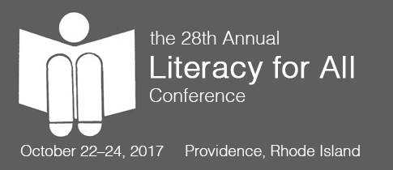
[Date]

[Your Name]
[Your Address]

[Supervisor’s Name]
[Address]

Dear [Supervisor’s Name],

(I/My team and I) would like to attend the 2017 Literacy for All Conference in Providence, Rhode Island from October 22-24, 2017. This renowned conference is the premier event for literacy professionals worldwide. Each year the Literacy for All Conference brings together educators from across the country and around the world helping them to build their literacy knowledge and learn from nationally recognized literacy leaders, educational experts and children’s literature authors.

The knowledge I gain will benefit [school/district]. At the 2017 Literacy for All Conference, I will gain (number of clock hours) clock hours and will also gain valuable information and useful resources from speakers, exhibitors, and other educators, which would greatly reduce the time and cost that [school name] would normally incur in exploring the topics. I will share this information with the staff of [school/district] to help others transform their teaching practice for the better, so that we are able to improve our overall performance. In addition, I’ll have the opportunity to connect with fellow educators to grow my professional learning community and learn new, effective teaching methods in play at other schools or districts.

The conference focuses on transforming lives through literacy, and I hope you will agree that attending the 2017 Literacy for All Conference would be a transformation opportunity for me as an educator and for [school/district]. If (I/we) register before September 1, 2017, (I/we) can save [school/district] a considerable amount of money. One more highlight, if four of our staff attend the conference for at least two days, a principal or superintendent can attend for FREE! Additionally, if we send ten of our staff for at least two days of the conference we may qualify to have an 11th person attend for FREE! Please consider prioritizing the funding for this professional development experience.

For your convenience, I have attached a detailed 2017 LFA Conference cost breakout on the following page. The opportunity for (me/us) to gain knowledge in (area of expertise) makes (my/our) attendance at the 2017 Literacy for All Conference a wise investment. Please feel free to visit the conference website (www.lesley.edu/literacyforall) for more information.

Many thanks in advance for your consideration.

Sincerely,

[Name]

2017 Literacy for All Conference Detailed Cost Breakout

The costs to attend the 2017 LFA Conference are the registration fee, travel expenses, hotel and a meal.

I would like to register for a Pre-conference session focusing on [insert topic here]. This full-day session provides a unique opportunity for me to [fill in the blank].

The total cost for the conference is [fill in blank].

Here is my estimated breakdown of costs:

Conference Registration Fee:
Airfare:
Transportation to/from Hotel:
Hotel:
Meals:

Total:

Thank you again for your consideration!

